Fix the Water, Not the Fish: Improving Reading Outcomes through Implementation Science

In a situation where the majority of fish in a body of water are dying, the only rational conclusion is that the water is dirty or poisoned. A deficit approach focuses on fixing the dying fish rather than the water that is killing them."
~Donna-Marie Winn and Marvin McKinney, Equity Consultants
Failure to Launch
I have always been concerned about educational equity. As a former special educator, I have an intimate understanding of how academically and socially vulnerable students often do not receive everything they need to be successful. Serving in schools where mostly Black students attended, I noticed that many were not receiving the interventions and instruction that would support their academic growth. My students had learning disabilities and were struggling readers, so I decided to get a master’s degree in Language and Literacy because I knew I was not equipped to appropriately teach reading. Though I gained invaluable skills and knowledge, I still struggled to implement what I learned into the classroom. I did not understand why I was not able to deliver instruction/intervention in the ways I’d learned in my master’s program. Why was it so hard? Why wasn’t I seeing the progress that I’d hoped for? How would I juggle content instruction while providing individualized reading interventions? It was perplexing and frustrating for me. I can only imagine how it felt to my students…
As I have been transitioning into my new role as a reading researcher, I have had the opportunity to “go behind the curtain” and to think about the levers and mechanisms at work that create obstacles for educators to deliver effective instruction and interventions. One thing I’ve learned is that teaching and learning do not operate in a bubble but are tied to larger social and political movements that trickle down to educators through legislation and policy. Unfortunately, the implementation of much of this policy, particularly as it pertains to reading education, often takes a deficit approach when a student’s race, disability status, language and economic status enters the conversation. Frequently, the interpretation of those policies is to “fix the fish,” meaning that the focus is on how to improve student achievement, while ignoring the inequitable conditions in which they live and learn-in other words, the water. We need to create the optimal conditions for successful implementation of evidence-based reading instruction so that our vision of improved student reading outcomes becomes a sustainable reality.

Failure to Thrive
What happens when a policy or initiative is not effectively implemented? As an example, let’s look at the landmark legislation of Brown v. the Board of Education of Topeka (1954) which effectively struck down the “separate but equal” mandate in schools across the United States, ending racial segregation. Without a formal plan of implementation, the legislation was left to states to interpret as they saw fit. The solution in many states was to dissolve Black schools, fire Black educators, and integrate Black students into white schools. Integration was more about moving Black students than it was in addressing the larger problems that led to racial segregation. Implementation of the law was as important as the ruling itself and the absence of an equitable, systematic desegregation plan has brought us full circle: to segregated schools. Though schools are more diverse, they are still highly segregated along racial, ethnic, and socio-economic status. However, with any failure comes lessons. The first is that implementation matters. The second is that policy that focuses on equality is not enough. Equality ensures everyone gets the same thing, which seems fair, but equity ensures everyone gets what they need to thrive. Implementation needs to be tempered with a focus on equity rather than just equality. What might have been the outcome if an equitable, systematic implementation plan was put in place centering the communities that desegregation impacted? The outcome may have been vastly different.
Despite school desegregation efforts, there is still considerable inequity in education overall, specifically in reading achievement. Data shows a persistent gap between Black students and their white peers in reading achievement. On the National Assessment of Educational Progress (NAEP, 2022), 83% of Black children in grade 4 scored below Proficient in 2022 compared to 58% of white students. This gap has widened due to the COVID-19 pandemic in 2020 which resulted in many schools switching to virtual learning. This matters because low reading achievement is associated to adverse outcomes across the lifespan, such as underemployment, decreased lifetime earnings, lower access to healthcare, and increased potential for incarceration (Mulcahy et al., n.d.). Segregated schools exacerbate this problem as race and socio-economic status are highly correlated and Black children are more likely to attend a school designated as a high poverty school (Analyst, 2020).

The Difference Between Sinking or Swimming

As a novice reading researcher, I see firsthand how the academy is grappling with the fact that our research seldom translates into classroom practice. There is a gap between what researchers know and what practitioners do. This is referred to as the “Know-Do Gap” or the research to practice gap. The difficulties that districts, schools, and educators experience in the uptake of evidence-based curriculum, intervention and innovations continues to be a challenge to improving student outcomes. The study of implementation science in education is a relatively new field of interdisciplinary inquiry concerned with the process of uptake, scaling, and sustaining of evidence-based practices and interventions with the overarching goal of improving student outcomes.
Numerous frameworks have been developed to help researchers and practitioners to bridge the Know/Do gap and work toward using more effective evidence-based innovations in the classroom. Equitable implementation processes ensure that implementation addresses the institutional and systemic barriers and impediments within districts, schools, and classrooms. One such set of frameworks is called the Active Implementation Frameworks developed by the National Implementation Research Network (NIRN) (see below). NIRN developed the Active Implementation Formula (AI) to demonstrate the necessary factors that lead to the uptake, implementation, and sustainability of evidence-based educational practices at scale.

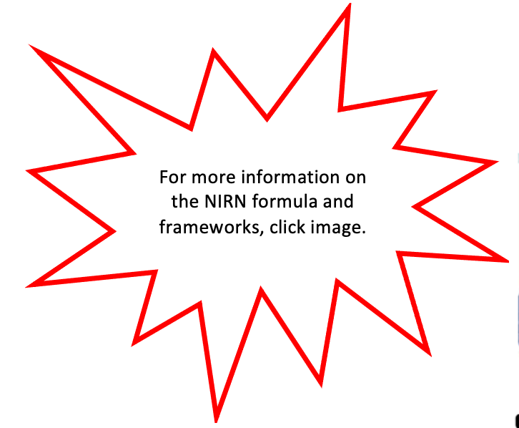
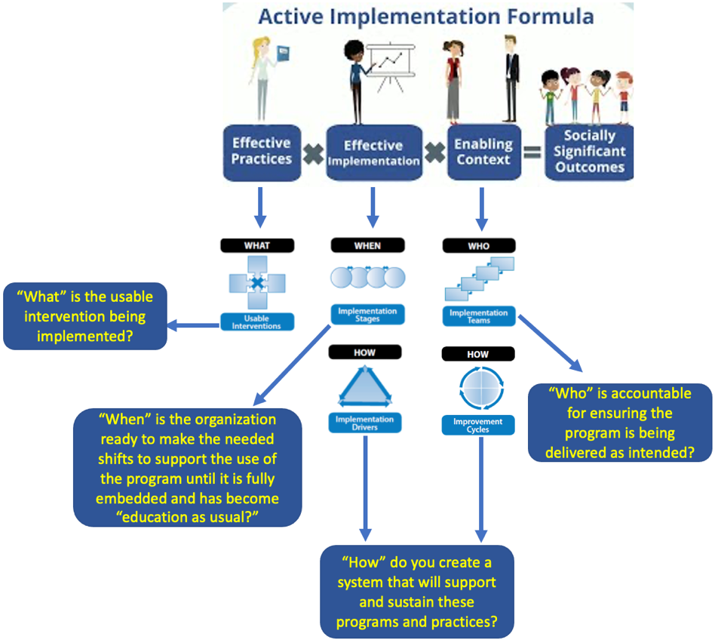

Adapted model from the National Implementation Research Network.

Implementation is a critical part of the adoption of educational initiatives as it offers a systematic approach to delivering policies, practices, instruction and interventions that have been deemed effective. The challenge with using this approach is that it runs counter to our desire for fast results. It takes time: time to look at data, time to find an evidence-based solution, time to form an implementation team, time to build trusting relationships, etc. Time, that as educators we do not feel that we have. However, think of all the failed reading initiatives that you have led or been involved with, be it a professional development cycle or a curriculum adoption that you had high hopes of improving instruction for your students. Calculate the time (and cost) of that initiative and all the others taking place in your district or school and the cost of starting over again and again. Not only does it waste time, but it also depletes precious resources and negatively impacts teacher development and morale. Worst of all, every new adoption or initiative is an interruption to student learning. Systematic, equitable implementation can be the difference between our students sinking or swimming.
Equitable Implementation: How to Begin Un-muddying the Water
We know why evidence-based reading instruction is important for the academic and holistic well-being of students, and how implementation science can improve conditions for instruction and learning. Let’s turn to equity. Implementation with a lens on equity is essential to shifting focus from “fixing” people to fixing the inequitable institutions and systems in which we continue to ask people to work, learn and live in despite the negative impacts they experience. Appropriately vetting all evidence-based innovations to ensure they are appropriate to the contexts and populations we serve, developing trusting relationships with those who will be impacted by the intended outcome, and reconsidering the usual top-down processes of decision-making are huge shifts to make. This is hard, uncomfortable work, but equitable implementation invites us into a process of transparency to make critical decisions alongside educators, students, and families. A first step can be to explore the NIRN AI Hub to learn more about how the AI formula and frameworks may be helpful in supporting you and your staff in your next adoption or policy initiative. You can start by watching this short video in Module 1 “An Overview for Active Implementation” and use the “Module 1 Notetaking and Reflection Guide” to jot down your thoughts. You can also check out this resource, “Bringing Equity to Implementation: Incorporating community experience to improve outcomes” that includes interesting examples of what equitable implementation looks like (Lopez, et al. 2021). In addition, the ExcelinEd Comprehensive How To Guide on Implementation of Early Literacy Practices is a great resource that tells the story of the “Mississippi Miracle” and the amazing progress in reading achievement-the result of successful policy and curriculum implementation. Finally, share this information with your colleagues and leadership team and form a study group to consider how equitable implementation can benefit your district or school. You will be well on your way to fixing the water, not the fish!

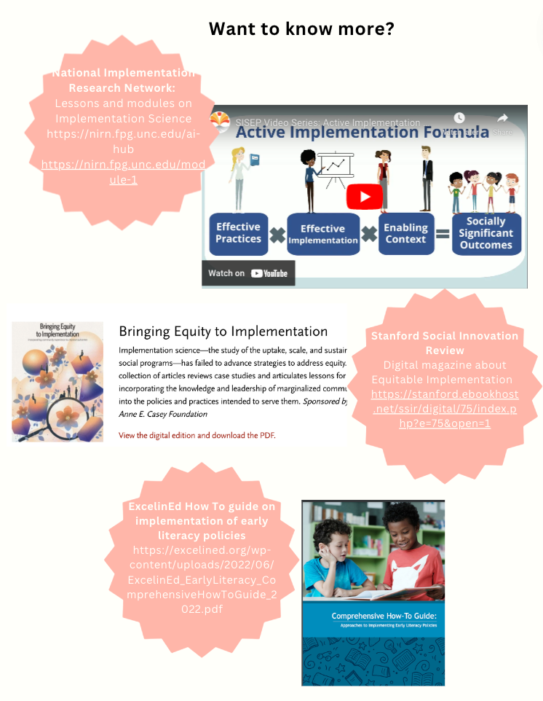

References
Analyst, A. J. C. S. R. (2020, June 23). Black Students in the Condition of Education 2020. Www.nsba.org. https://www.nsba.org/Perspectives/2020/black-students-condition-education
Mulcahy, E., Bernardes, E., & Baars, S. (2019). The relationship between reading age, education and life outcomes LKMco -The education and youth “think and-action” tank. https://www.cfey.org/wp-content/uploads/2019/03/The-relationship-between-reading-age-education-and-life-outcomes.pdf
NAEP Reading: National Achievement-Level Results. (2022). Nationsreportcard.gov. https://www.nationsreportcard.gov/reading/nation/achievement/?grade=4

